**G(L)O Clouds!**

***OSINT***

**Challenge:**

Alejandro has been seen as an easy mark for DEADFACE. Do a sweep of his social media to see what information DEADFACE was able to gather on Alejandro. Scroll through Alejandro's social media to find out the degree he graduated with, from what school, and in what year.

Submit the flag as: flag{school-initials_degree-program_year}. Example: flag{LSU-politicalscience-87}.

**Approach:**

So we see the discussion on the forum and get Alejandro’s facebook profile from there.

Upon scrolling down in his timeline, we see the required information:

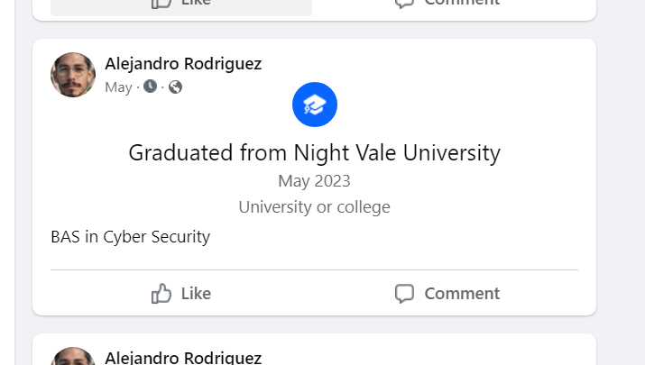

Hence our flag:

**Flag: flag{NVU-cybersecurity-23}**

Congrats!!

Happy Hacking!